1.1
1.2
1.3
1.4
1.5
1.6
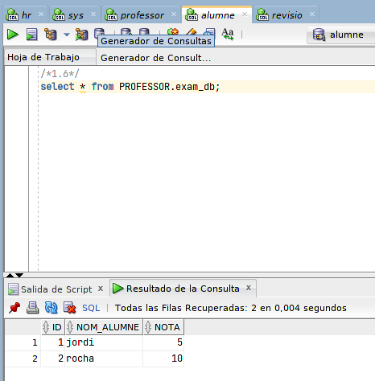

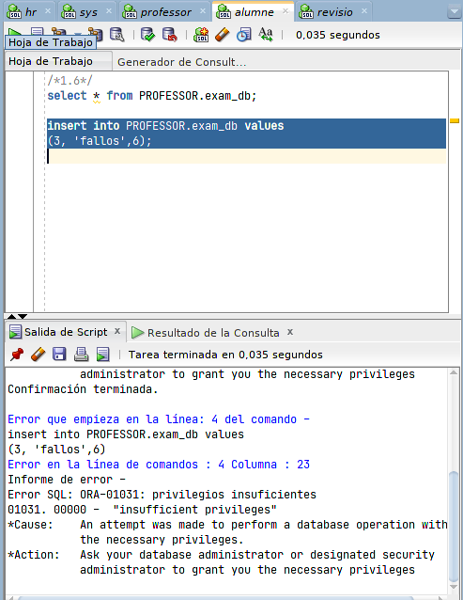

/*1.6*/
select * from PROFESSOR.exam_db;

insert into PROFESSOR.exam_db values
(3, 'fallos',6);

1.7

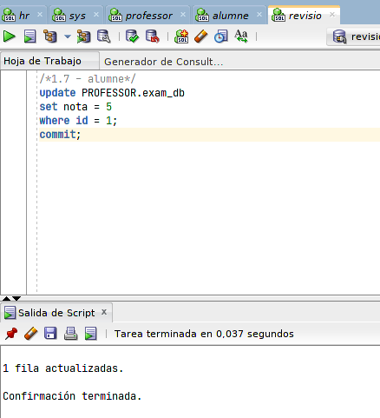

1.8
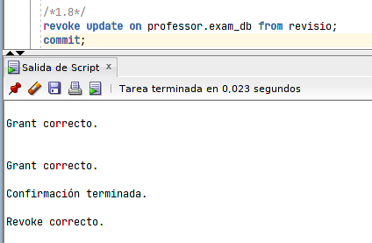

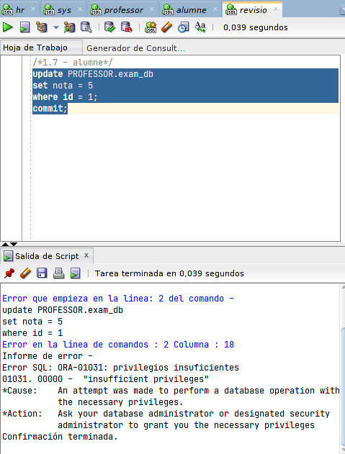

1.9

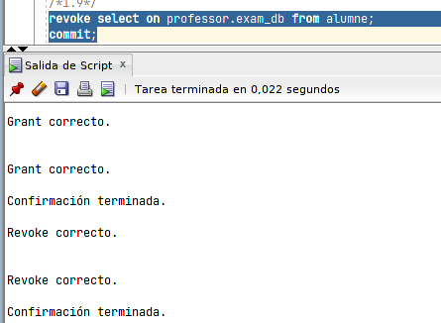

1.10
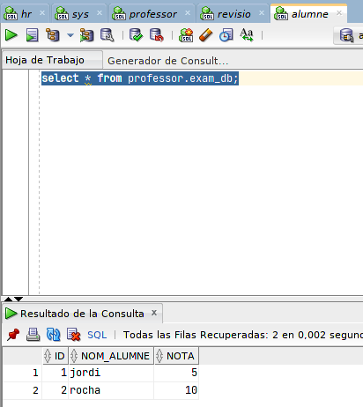

sigue siendeo capaz y eso que he quitado los permisos.

/*resultados con sys*/

/*1.1*/
create user professor IDENTIFIED BY 123;
alter user professor quota 2m on users; /*no podia crear tablas*/
commit;
/*1.2*/
create role informatica;

grant create session, create table to informatica;

grant insert any table, update any table to informatica;

commit;

grant informatica to professor;
commit;

/*1.4*/
create user alumne IDENTIFIED BY alumne;

grant create session to alumne;
commit;
grant select on professor.exam_db to alumne;
commit;

/*1.7*/
create user revisio IDENTIFIED BY revisio
quota 2m on users;
grant create session to revisio;
grant update on professor.exam_db to revisio;
commit;

/*1.8*/
revoke update on professor.exam_db from revisio;
commit;
/*1.9*/
revoke select on professor.exam_db from alumne;
commit;

/*professor*/
/*1.3*/
CREATE TABLE exam_db (
id NUMBER(4),
nom_alumne VARCHAR2(10),
nota NUMBER(2)
);
commit;
/*1.5*/
insert into exam_db values
(1, 'jordi',4);

insert into exam_db values
(2, 'rocha',10);
commit;
select * from exam_db;

/*revisio*/
/*1.7 - alumne*/
update PROFESSOR.exam_db
set nota = 5
where id = 1;
commit;

/*alumne*/
select * from PROFESSOR.exam_db;
commit;

